Copying links within a topic does not work
Example:
Copied message link 10688 into the clipboard
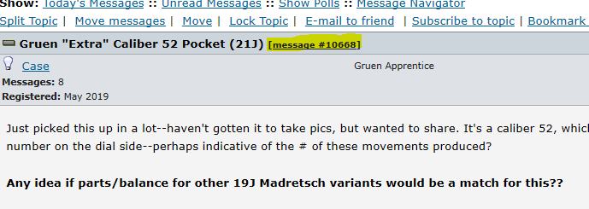

Inserting the link into a new message
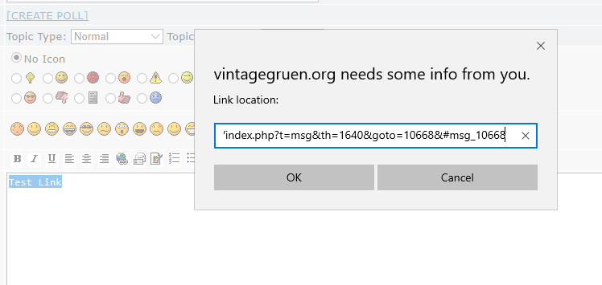

Preview of the inserted link. Looks like a space inserted in the highlighted area might be suspect causing the link not do display correctly.
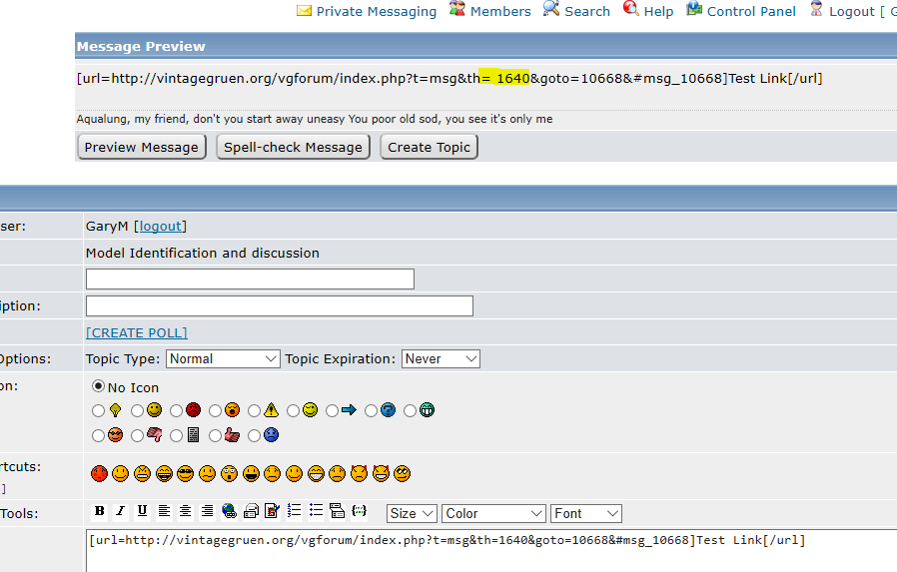
The workaround is to find the topic in the main forum and copy that link.


