I have created a topic call “学英语”. (as shown below)

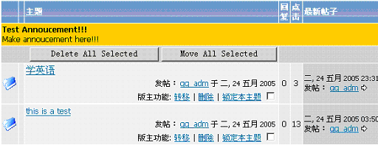

Replied to the topic with the message "写下一点意见，如何学好英语". (as shown below)

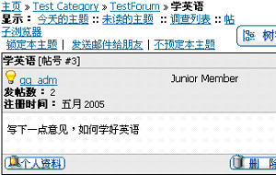

Did a search on the phrase "英语" and nothing is returned. (as shown below)

